2015

Ruska Award

Student Microscopy Competition

CALL FOR ENTRIES

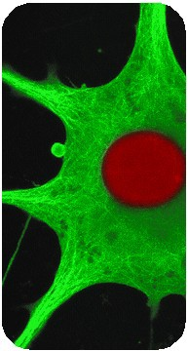
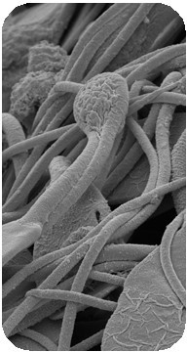
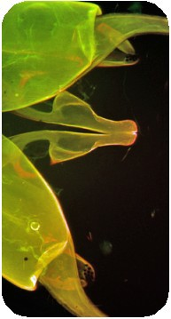
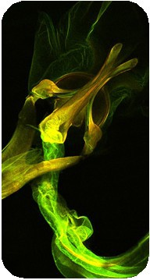
Open to undergraduate and graduate students Participants receive registration, housing, banquet ticket, and certificate of registration
Winner receives Ruska Award plaque and $300!

Deadline for Submission: April 17th

For more information, scan the QR code or visit www.southeasternmicroscopy.org/ruska-award-student-competition/ For further inquiries,
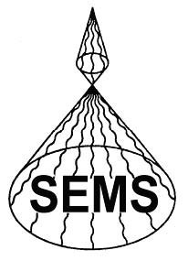
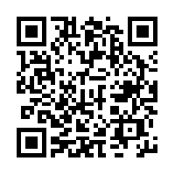
contact Amanda Lawrence at alawrence@i2at.msstate.edu or 662-325-3019

Brought to you by
Southeastern Microscopy Society

